Join Us for the 2020 Annual

Four Corners Quilters Gathering
Friday-Sunday, April 3-5, 2020 in Durango, Colorado

Special Guest  Cindy Needham  Instructor and Designer | 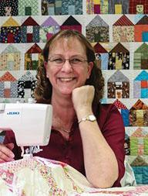

Workshop & Luncheon Schedule

FRIDAY — Location to be determined
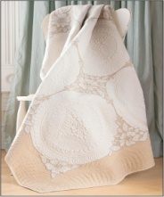 | 9:00-12:00 am Wholecloth Linen Quilts $40  This fun, hands-on lecture will give you all the tips and tricks you'll need to create beautiful wholecloth quilts out of ordinary linens. Cindy will take you thru the process step-by-step including stain removal, edgings, working with lace and designing.
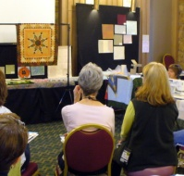 | 1:30-4:30 pm DESIGN-A-RAMA $40  Cindy will be pulling out the best part of her 5-day design workshop and teaching you the basics of designing your pieced tops by dividing and conquering your space. Each student is to bring an unquilted, pieced top. We will hang each top and then design it as a group using all the information Cindy shares in the lecture. The maker of the top will leave with oodles of ideas for designing. This is a lot of fun and you will leave inspired and a bit overwhelmed.

SATURDAY — Durango Public Library, 1900 East 3rd Avenue, $35
Registration: 9:30-10:00 am
10:00-Noon: Western Slope’s best show and tell! Bring 1-2 items.
Noon-1:00: LUNCHEON
1:00-2:30: | LECTURE - FOR THE LOVE OF LINENS  During Cindy's one-hour trunk show she shares the stories and how-to-techniques behind each of her wholecloth linen quilts. Many of these were part of her 2016 featured exhibit at the Houston Quilt Festival. She will also be sharing many of her new pieced linen quilts. Best part of the program is the fondling of the quilts afterwards!
2:30 pm: | Guild Reps Meet Briefly

SUNDAY —Location to be determined
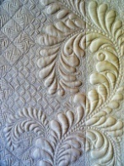 | 9:00-4:00 pm HEIRLOOM FEATHERS & BACKGROUNDS $70 (+ $15 kit fee)  One of the best loved quilting designs of all times is the feather and it seems to be one of the more difficult ones to beautifully quilt. Cindy will teach you to how quilt feathers and enjoys making them your own by adding special touches and details. Cindy will teach you to fill open spaces with beautifully detailed background designs. It’s usually a beautiful background that provides the “WOW” factor to a quilt.

Sweetheart of a Deal! — First 20 to sign up for all 3 classes by
Valentine's Day (February 14) save $15.00.

I have been an obsessive quilter for over 45 years starting as a hand quilter when I was in the 8th grade. I loved the process of hand quilting but found I couldn't keep up with my quilt tops and finally had to learn to machine quilt. It was a very difficult journey, and not easy, but after many months of practice I finally got my rhythm and fell head over heels in love with the art of machine quilting.
In the late 90's I became a bit bored quilting on "regular" pieced quilt tops and decided to try my hand at quilting a tattered linen that was on my night stand. I marked it with a beautiful design, put it in my machine, and created the world's very first linen wholecloth quilt. It was a moment that changed my life forever. Not only had I created something fabulous out of an ordinary linen but it justified my huge linen stash! Now I had to make more of them!

2020 Four Corners Quilters Gathering
Registration Form

Sweetheart of a Deal Deadline — February 14th
Luncheon Only Deadline – March 15th (Sorry, no refunds)

Name: ______________________________________________________________________________
Address: ____________________________________________________________________________
City: _________________________________ State: ________________ Zip: ____________________
Phone: ________________________ E-Mail: ______________________________________________

- Wholecloth linen quilts - Morning (april 3) $40.00 $ __________
- Design-a-rama – afternoon (april 3) $40.00 $ __________
- Heirloom Feathers & backgrounds (april 5) $70 +$15 kit fee $ __________
- Luncheon and Lecture (April 4) - $35.00 $ __________
TOTAL $ __________

OR …
for FIRST 20 TO REGISTER:
Sweetheart of a Deal–Both Friday classes - $70.00 (Save $10) $ _________
- Wholecloth Linen Quilts and Design-A-Rama (April 3)
- OR
- Friday and Sunday Classes (April 5) - $135.00 + $15.00 kit fee ..…. $ _________
Luncheon and Lecture (April 13) - $35.00 $ _________

TOTAL $ _________

Make checks payable to: Four Corners Quilters
Mail to: Four Corners Quilters, c/o Barb Morgan 382 Cole Ranch Rd., Durango, CO 81303

QUESTIONS: Barb Morgan (970) 259-1079; Jill Fischer (970) 375-9744.

E-mail: barbmorgan24@gmail.com… Friend Us on Facebook at Four Corners Quilters.

